The Case of the Mountain King

Dear Miss White,
A long time ago I worked with a king who lived in a faraway castle. He had something important that he wanted to protect behind a large wooden door. He asked me to help him lock it away. So to get to the door you must open 9 locks on the doors in the castle. But now he wants to open the door. Please go to the castle and help him.
Here is the pattern to open the locks:
Turn the lock around, around
handle up, handle down
slide and slide and slide and slide and
reach up to the top.
Watch out for the last door – the locks tend to stick.
I never found out what was hidden behind the wooden door. What do you think it is?

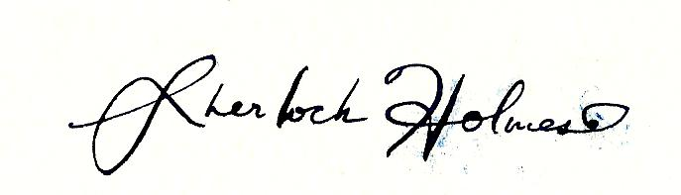
Sincerely,

